**SECTION A**

1. Outline four characteristics of a good pasture plant (4 marks) ………………………………………………………………………………………………… ………………………………………………………………………………………………… ………………………………………………………………………………………………… ………………………………………………………………………………………………… ………………………………………………………………………………………………… …………………………………………………………………………………………………

b. Differentiate between silage and hay (4 marks) ……………………………………………………………………………………………… ………………………………………………………………………………………………… ………………………………………………………………………………………………… ………………………………………………………………………………………………… ………………………………………………………………………………………………… …………………………………………………………………………………………………

c. As an upcoming agriculturalist, explain the precautions taken while making good quality silage (2 marks) ………………………………………………………………………………………………… ………………………………………………………………………………………………… ………………………………………………………………………………………………… ………………………………………………………………………………………………… ………………………….…………………………………………………………………… ………………………………………………………………………………………………… …………………………………………………………………………………………….…

2a). differentiate between natural and artificial incubation. (2 mark) ……………………………………………………………………………………………… ………………………………………………………………………………………………… ………………………………………………………………………………………………… …………………………………………………………………………………………………

(b) State four advantages of natural incubation. (4 mark) ………………………………………………………………………………………………… ………………………………………………………………………………………………… ………………………………………………………………………………………………… …………………………………………………………………………………………………

c) Mention the factors affecting incubation. (4marks) ………………………………………………………………………………………………… ………………………………………………………………………………………………… ………………………………………………………………………………………………… ………………………………………………………………………………………………… ………………………………………………………………………………………………… ………………………………………………………………………………………………… ………………………………………………………………………………………………… …………………………………………………………………………………………………

3a) What is soil sampling (2 marks) ………………………………………… ………………………………………………………………………………………………… ………………………………………………………………………………………………… …………………………………………………………………………………………………

b) Mention the various methods of carrying out soil sampling (2 marks) ………………………………………………………………………………………………… ………………………………………………………………………………………………… ………………………………………………………………………………………………… …………………………………………………………………………………………………

c).Outline the objectives of soil sampling (6 marks) ………………………………………………………………………………………………… ………………………………………………………………………………………………… ………………………………………………………………………………………………… ………………………………………………………………………………………………… ………………………………………………………………………………………………… ………………………………………………………………………………………………… ………………………………………………………………………………………………… …………………………………………………………………………………………………

4a). What is inventory record (2 marks) ………………………………………………… ………………………………………………………………………………………………… ……………………………………………………………………………………………

b) Apart from inventory records, mention four other types of records kept on a farm (4 marks) ………………………………………………………………………………………………… ………………………………………………………………………………………………… ………………………………………………………………………………………………… …………………………………………………………………………………………………

c) List four reasons as to why farmers keep farm records in Agricultural production (4 marks) ………………………………………………………………………………………………… ………………………………………………………………………………………………… ………………………………………………………………………………………………… ………………………………………………………………………………………………… ………………………………………………………………………………………………… ………………………………………………………………………………………………… ………………………………………………………………………………………………… …………………………………………………………………………………………………

5. Write short notes about the following breeding systems; ( 5 marks).

i) cross breeding.

…………………………………………………………………………………………………………………………………………………………………………………………………………………………………………………………………………………………………………………………………..

ii). Up_grading.

…………………………………………………………………………………………………………………………………………………………………………………………………………………………………………………………………………………………………………………………………..

iii). In-breeding.

……………………………………………………………………………………………………………………………………………………………………………………………………………………………………………………………………………………………………………………………………

iv). Line- breeding

……………………………………………………………………………………………………………………………………………………………………………………………………………………………………………………………………………………………………………………………………

v). Out breeding

……………………………………………………………………………………………………………………………………………………………………………………………………………………………………………………………………………………………………………………………………

(b). State reasons for improving livestock. ( 5 marks).

……………………………………………………………………………………………………………………………………………………………………………………………………………………………………………………………………………………………………………………………………………………………………………………………………………………………………………………………………………………………………………………………………………………………………………………………………………………………………………………………………………………………………………………………………………………………………………………………………………………………………………

**SECTION B**

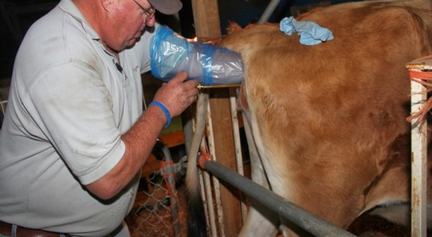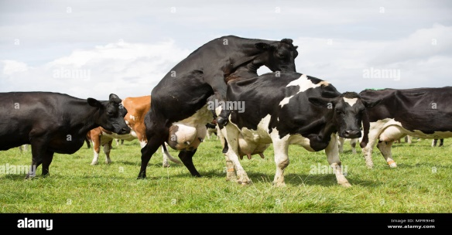

Muwonge a local cattle farmer with local breeds of cattle. He would love to upgrade his cattle with sperms from the brown Swiss bull found only at the National Agricultural Research institute in Entebbe. The semen can be delivered to him along with the inseminating officer to help him inseminate his cows in case they are on heat, should he make that phone call to the research station. Muwonge is not sure of when to make that phone call as he can not identify when his cow is on heat.

TASK.

As an agricultural student, write a detailed essay advising Muwonge on the specific signs he should look out for before making that call to the National Agricultural Research Institute. (20 points)